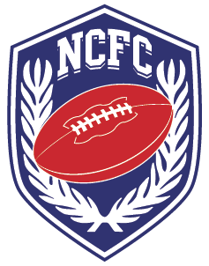
NCFC General Assembly Agenda
February 19, 2021

- Establish Quorum (Andreas)
- Call to Order (Andreas)
- Review and approve minutes (Andreas)
- Review and approve agenda (Andreas)
- Committee Reports:
  - Officials Report (Dave Curschman)
  - Commissioners Report (Gary)
    - Budget
    - Director of Operations Hiring Committee
  - President’s Report (Andreas)
    - Legislative item – Review
    - Padded Spring Ball (Collection of data) - Discussion
    - Presto increases - David
    - Dues for 2021/22 – Discussion
    - Summer meeting – Discussion
  - Competition Committee Report (Christine)
  - Constitution Committee Report (Steve)
  - CCCFCA Report (Craig Thompson)
  - Athletic Trainers Report (Jasmine)
- Selection of League reps
- Review Legislation and vote
  - Review P1, P2, P3, P4, P5, P6, P7, P8, P12, P16, P17
- Other
- Adjourn

